SOFTWARE REQUIREMENTS DOCUMENT
Virtual Card Platform - Authentication System
Date: October 28, 2025
1.0 INTRODUCTION
1.1 Purpose
This document specifies the requirements for the Authentication Module of the Virtual Card Platform. The system provides secure user registration, login, and management capabilities using Node.js, Express.js, and MySQL WorkBench
1.2 Scope
The authentication system handles user identity management including registration, authentication, and user data retrieval. This module serves as the foundation for future virtual card functionality.
1.3 Definitions
- JWT: JSON Web Token for secure authentication
- MVC: Model-View-Controller architectural pattern
- bcrypt: Password hashing algorithm
- REST API: Representational State Transfer API

2.0 OVERALL DESCRIPTION
2.1 Product Perspective
The authentication system is a standalone module that will integrate with future virtual card services including card issuance, transactions, and account management.
2.2 User Classes
- End Users: Register and authenticate to access the platform
- Administrators: View all registered users (for management purposes)
2.3 Operating Environment
- Backend: Node.js v18+ with Express.js framework
- Database: MySQL 8.0+
- Authentication: JWT tokens
- Security: bcrypt password hashing
2.4 Design Constraints
- Must follow MVC architecture pattern
- Must use MySQL as database engine
- Must implement password hashing
- Must provide RESTful API endpoints
3.0 FUNCTIONAL REQUIREMENTS
3.1 User Registration (FR-001)
3.1.1 Description
Allows new users to create an account in the system with personal information.
3.1.2 Input Parameters
Field | Type | Required | Validation | Description
Firstname | string | Yes | 2-100 characters | User's first name
Lastname | string | Yes | 2-100 characters | User's last name
Email | string | Yes | Valid email format | Unique user email
Phone-number | string | No | 10-15 characters | Contact number
Address | string | No | Text field | Physical address
Password | string | Yes | 6+ characters | Account password
DOB | date | No | YYYY-MM-DD format | Date of birth

4.0 NON-FUNCTIONAL REQUIREMENTS
4.1 Performance Requirements
- Response Time: < 2 seconds for all API calls
- Concurrent Users: Support for 1000+ simultaneous users
- Availability: 99.5% uptime
4.2 Security Requirements
- Password Storage: bcrypt hashing with salt rounds 10
- Authentication: JWT tokens with 24-hour expiration
- Data Validation: Input sanitization and validation
- CORS: Enabled for cross-origin requests
4.3 Reliability Requirements
- Error Handling: Comprehensive error messages and logging
- Data Integrity: MySQL transactions and constraints
- Backup: Regular database backups
4.4 Usability Requirements
- API Documentation: Clear endpoint documentation
- Error Messages: User-friendly error responses
- Consistency: Standardized response formats
5.0 TECHNICAL SPECIFICATIONS
5.1 Database Schema
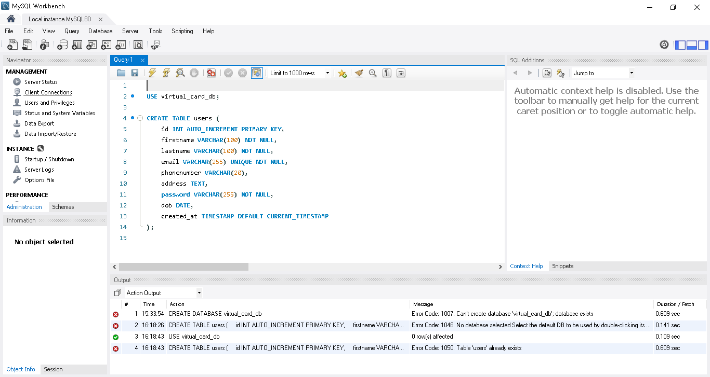
5.2 API Endpoints Summary
Method | Endpoint | Description | Authentication
POST | /v1/api/auth/register | User registration | None
POST | /v1/api/auth/login | User login | None
GET | /v1/api/users | Get all users | JWT Token

5.4 Technology Stack
- Runtime: Node.js v18+
- Framework: Express.js
- Database: MySQL with mysql2 driver
- Authentication: jsonwebtoken
- Security: bcryptjs, cors
- Development: nodemon, dotenv
6.0 DATA REQUIREMENTS
6.1 Data Storage
- User credentials (hashed)
- Personal information
- Timestamps for auditing
6.2 Data Privacy
- Passwords never stored in plain text
- Personal data encrypted at rest
- Compliance with data protection regulations

